Analysis of Real-Time Object Detection Using YOLO
Project Report — Module 2

1. Abstract
Object detection is an important component of modern Autonomous Vehicle (AV) systems. An autonomous vehicle must identify surrounding objects such as cars, pedestrians, buses, motorcycles and traffic-related objects in real time to understand its environment.
This project presents an analysis of real-time object detection using the YOLO (You Only Look Once) object detection approach. YOLO processes an input image or video frame and identifies multiple objects along with their class labels and confidence scores. The system is designed to demonstrate how real-time object detection can support perception systems in autonomous vehicles.
The project focuses on the detection process, real-time performance, confidence-based predictions and the suitability of YOLO for automotive applications. The implementation uses Python and a YOLO model with OpenCV for video/image processing.

2. Introduction
Autonomous vehicles require a perception system capable of continuously understanding the environment surrounding the vehicle. Cameras are commonly used to capture visual information, while object detection algorithms process this information to identify relevant objects.
Traditional image-processing approaches can require multiple processing stages and may have difficulty achieving real-time performance. YOLO addresses object detection as a single detection problem, allowing objects to be detected directly from an image.
In an automotive environment, real-time object detection can be used to identify vehicles, pedestrians and other objects around the vehicle. The detected information can subsequently be used by higher-level decision-making and control systems.
The Module 2 project requirement specifically focuses on the analysis of real-time object detection using YOLO.

3. Problem Statement
An autonomous vehicle needs to detect objects around it quickly and reliably. Delayed or incorrect object detection can affect subsequent perception and decision-making processes.
Therefore, the objective of this project is to implement and analyze a YOLO-based real-time object detection system and study its suitability for applications in autonomous vehicles.

4. Objectives
- To understand the working principle of YOLO-based object detection.
- To implement real-time object detection using Python.
- To detect multiple objects in images or video.
- To display detected object classes and confidence scores.
- To analyze the real-time performance of the detection system.
- To understand the application of YOLO in autonomous vehicle perception.
- To identify the advantages and limitations of YOLO for automotive applications.

5. Technology Used
Category | Components
Software | Python, OpenCV, YOLO, NumPy, Visual Studio Code / Jupyter Notebook
Hardware | Computer/Laptop, Webcam or prerecorded video, Optional GPU for faster processing

6. YOLO Overview
YOLO stands for You Only Look Once. It is an object detection approach designed to perform object detection efficiently.
Instead of processing different regions of an image separately, YOLO processes the complete image and predicts object locations and classes in a single detection process.
The output of the detection system contains:
- Bounding box
- Object class
- Confidence score
For example, a camera frame may contain several vehicles and pedestrians. YOLO can identify these objects and draw bounding boxes around them.

7. System Architecture
The proposed system follows the processing pipeline shown below.
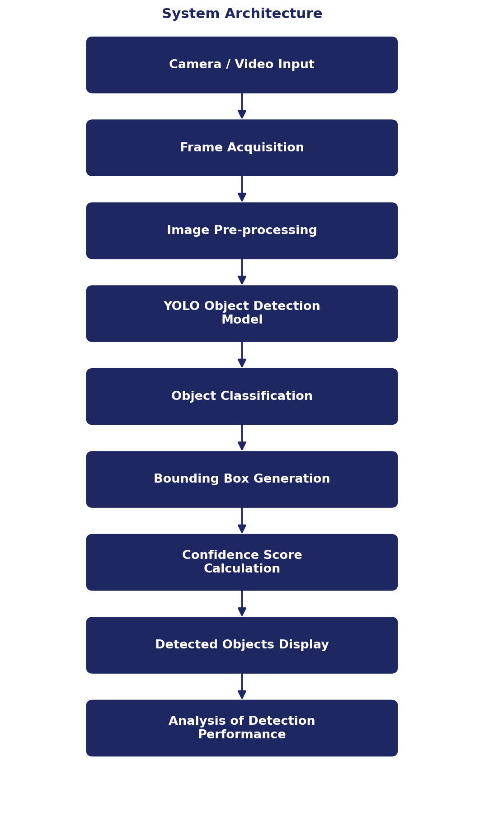
Figure 1. YOLO-based real-time object detection system architecture.

Architecture Description
The camera or video provides input frames to the system. Each frame is processed by the YOLO model. The model identifies objects present in the frame and produces bounding boxes and confidence values.
The processed frame is then displayed with the detected objects marked on it.

8. Methodology
The project is implemented using the following steps.

Step 1: Input Acquisition
The system receives an image, prerecorded video or live webcam feed.

Step 2: Frame Processing
For video input, individual frames are extracted continuously.

Step 3: YOLO Detection
Each frame is passed to the YOLO model. The model predicts objects present in the scene.

Step 4: Object Classification
Detected objects are assigned class labels such as:
- Person
- Car
- Bus
- Truck
- Motorcycle
- Bicycle
depending on the classes supported by the selected model.

Step 5: Confidence Filtering
Each prediction contains a confidence value. Predictions below the selected confidence threshold can be ignored.

Step 6: Visualization
Bounding boxes, class names and confidence scores are displayed on the frame.

Step 7: Performance Analysis
The system can be evaluated based on:
- Detection accuracy
- Confidence of predictions
- Processing speed
- Number of detected objects
- Real-time responsiveness

9. Implementation
The following Python implementation uses a YOLO model and OpenCV.
from ultralytics import YOLO
import cv2
# Load YOLO model
model = YOLO("yolo11n.pt")
# Open webcam
cap = cv2.VideoCapture(0)
while True:
ret, frame = cap.read()
if not ret:
break
# Run YOLO detection
results = model(frame)
# Draw detection results
annotated_frame = results[0].plot()
# Display frame
cv2.imshow("YOLO Real-Time Object Detection", annotated_frame)
# Press q to exit
if cv2.waitKey(1) & 0xFF == ord("q"):
break
cap.release()
cv2.destroyAllWindows()

Code Explanation
- YOLO() loads the trained YOLO model.
- cv2.VideoCapture(0) accesses the computer's webcam.
- The while loop continuously captures video frames.
- The YOLO model processes every captured frame and identifies objects.
- results[0].plot() generates an annotated frame containing bounding boxes and labels.
- cv2.imshow() displays the processed frame.
- Pressing q terminates the program.

10. Detection Output
The system produces an annotated video frame containing:
- Bounding boxes around detected objects
- Object class names
- Confidence scores
For example, if a vehicle is detected, the output may contain:
Sample Detection
Class: car
Confidence: 0.91

Screenshot to Insert
Figure 2: YOLO real-time object detection output — insert a screenshot of your running YOLO window here showing detected objects.

11. Testing
The system can be tested using different environments.
Test Case | Input | Expected Result
1. Single Object | One clearly visible vehicle | System detects the vehicle and displays a bounding box and confidence score.
2. Multiple Vehicles | Several vehicles | System identifies multiple vehicles and draws separate bounding boxes.
3. Pedestrian and Vehicle | Pedestrians and vehicles | System identifies the different object classes separately.
4. Complex Scene | Multiple objects and background elements | System attempts to detect the supported object classes while maintaining real-time operation.

12. Performance Analysis
The performance of a real-time object detection system can be analyzed using the following parameters:
Parameter | Description
Detection Accuracy | Ability to correctly identify objects
Confidence Score | Confidence associated with each prediction
Processing Speed | Number of frames processed per second
Detection Range | Distance at which objects can be visually detected
False Detection | Incorrect identification of an object
Missed Detection | Failure to detect an existing object

The actual performance depends on the selected YOLO model, input resolution, hardware, lighting and environmental conditions.

13. Application in Autonomous Vehicles
YOLO-based object detection can form part of the perception layer of an autonomous vehicle. A simplified automotive perception pipeline can be represented as shown below.
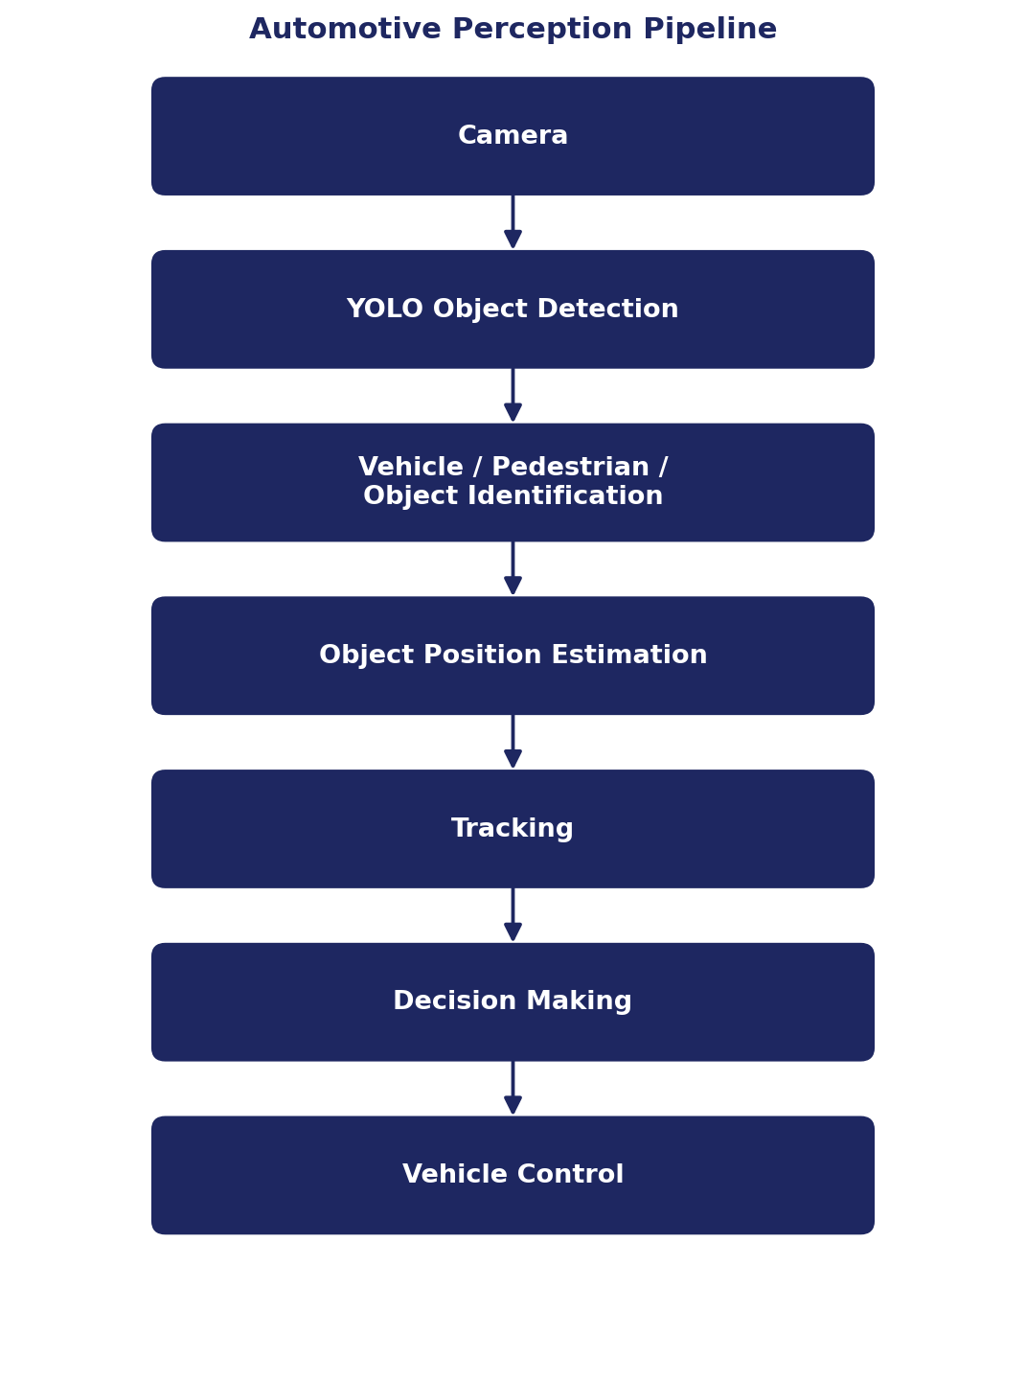
Figure 3. Simplified automotive perception pipeline.
For example, if a pedestrian is detected in front of the vehicle, the perception system can provide this information to a higher-level decision-making system. The decision system can then determine an appropriate action such as slowing down or stopping.
YOLO itself is primarily responsible for object detection; it does not independently perform the complete autonomous-driving decision and control process.

14. Advantages
- Real-time object detection capability.
- Detection of multiple objects in a single frame.
- Simple integration with Python and OpenCV.
- Suitable for camera-based perception applications.
- Bounding boxes and confidence scores provide useful perception information.
- Can be deployed on suitable computing hardware for real-time applications.

15. Limitations
- Detection performance depends on image quality.
- Low-light conditions can affect camera-based detection.
- Small or partially occluded objects may be difficult to detect.
- Processing speed depends on hardware.
- A detection model alone does not provide complete autonomous-driving functionality.
- Additional tracking, localization, sensor fusion and decision-making systems may be required in a complete autonomous vehicle.

16. Future Scope
- Integration with vehicle cameras.
- Integration with LiDAR or radar information.
- Multi-object tracking.
- Distance estimation.
- Lane detection.
- Traffic-sign and traffic-light detection.
- Deployment on embedded automotive hardware.
- Integration with ROS or autonomous-driving simulation platforms.
- Integration with a decision-making and vehicle-control system.

17. Result
A YOLO-based real-time object detection system was designed and analyzed. The system accepts image or video input and identifies supported objects using bounding boxes, class labels and confidence scores.
The project demonstrates how computer-vision-based object detection can contribute to the perception layer of an autonomous vehicle.
The observed detection performance depends on the selected model, hardware, image quality and environmental conditions. The project therefore provides a practical foundation for understanding real-time perception in autonomous vehicles.

18. Conclusion
This project demonstrated the use of YOLO for real-time object detection and analyzed its suitability for autonomous vehicle applications.
The system can identify multiple objects from camera input and provide their corresponding bounding boxes and confidence scores. Such information is an important input to an autonomous vehicle's perception pipeline.
Although YOLO alone cannot perform complete autonomous driving, it can serve as an important component of an automotive perception system. Further integration with object tracking, sensor fusion, localization, path planning and vehicle control can transform the basic detection system into a more complete autonomous-driving solution.

19. References
1. YOLO object detection documentation.
2. OpenCV documentation.
3. Python documentation.
4. Ultralytics YOLO documentation.
5. Module 2 Autonomous Project Assignment provided for the project.

